Testimonial
- Company Name: Huifeng Seed Company
- Plant Date: 2011 4 28
- Plants Type: Corn
- Treatment Method: Treated with NG VS. Untreated
- Record Period: Every 3 days
- Record With Photo
- The Final Result Includes:
- Treatment Method
Dissolved 1 pellet of NG per 1L of water,then poured water into a catch basin for 20 seconds in order to fully soak the seeds. The seeds were dried away from direct sunlight.
- Output Total
 | Category | Numbers | Lines | Grain Weight of 1000  （g） | Fresh Weight  （kg） | Dry Weight  （kg） | Total Weight  （kg）
Treated | Ludan 981 | 16.00 | 32.67 | 244 | 4.80 | 0.68 | 696
Untreated | Ludan 981 | 15.67 | 34 | 221 | 3.98 | 0.59 | 631
increase |  | 2.13% | -3.92% | 10.41% | 20.60% | 15.25% | 10.30%

- Comparison with root and appearance
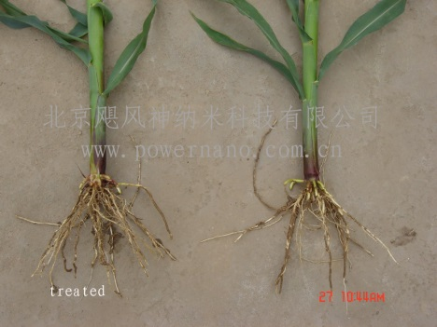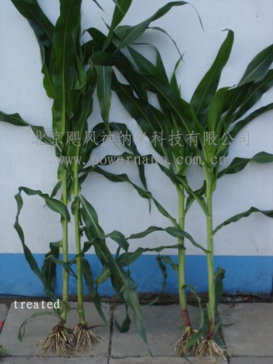
- Comparison in the field

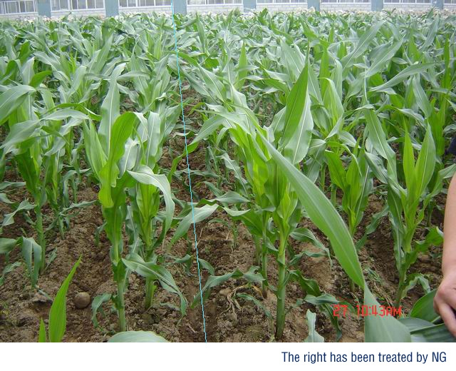

- Summary Note:
The corn that was treated all improved their height, radicel’s number, caudex’s diameter. The leaf colour is deeper and stronger than untreated. Those can prove they have more power for bad environment.
The corn cob grows better and sooner, the grain has more weight. Colour is more bright. Quality is better than untreated.
After this test we know NG is a great product which can help corn grow better. It can be recommended to be used in all corn fields.
I can say NG is the best product for treating corn seed based upon what I have seen.

